FirstAid+: A Web-Integrated Platform for Providing Step-by-Step Emergency Health Assistance

Glycel C. Paran  
*College of Technology  
Bohol Island State University-Bilar Campus*Bilar, Bohol, Philippines  
[glycel.paran@bisu.edu.ph](mailto:glycel.paran@bisu.edu.ph)  
  
Darrel A. Cardaña  
*College of Technology  
Bohol Island State University-Bilar Campus*Bilar, Bohol, Philippines  
[darrel.cardana@bisu.edu.ph](mailto:darrel.cardana@bisu.edu.ph)

Max Angelo D. Perin  
*College of Technology  
Bohol Island State University-Bilar Campus*Bilar, Bohol, Philippines  
[maxangelo.perin@bisu.edu.ph](mailto:maxangelo.perin@bisu.edu.ph)

Cecilia T. Gumanoy  
*College of Technology  
Bohol Island State University-Bilar Campus*Bilar, Bohol, Philippines  
[cecilia.gumanoy@bisu.edu.ph](mailto:cecilia.gumanoy@bisu.edu.ph)

*Abstract*— FirstAid+: A Web-Integrated Platform for Providing Step-by-Step Emergency Health Assistance is a responsive web application designed to deliver real-time, easy-to-follow instructions for handling common medical emergencies such as CPR, choking, bleeding, burns, and fractures. Aimed at non-medical responders and the general public, the platform provides a centralized, user-friendly interface to guide users through critical situations while also serving as a tool for health education and preparedness. Built with modern frontend technologies like Vite, React, TypeScript, and Tailwind CSS, and powered by Supabase for backend services including real-time data access and secure user authentication, FirstAid+ ensures quick, reliable, and device-friendly access to life-saving information. By bridging the gap between emergencies and immediate action, the platform supports digital health literacy, encourages community readiness, and lays the groundwork for future enhancements such as offline access, multi-language support, and intelligent symptom guidance.

Keywords—Emergency Health Assistance, Health Education, Medical preparedness, Web Integrated Platform, Responsive design, React, TypeScript, Vite, Tailwind CSS

# Introduction

When emergencies happen, many people don’t know how to respond quickly or correctly because they haven’t had easy access to clear first aid guidance. This problem is especially common among students and young adults, who might not have had formal training or practical experience with first aid. In those critical moments, hesitation or confusion can make things worse for the person in need. Traditional methods like pamphlets or occasional health classes aren’t enough—they don’t provide immediate, easy-to-follow instructions when every second counts. Although there are some digital health tools out there, most aren’t designed to guide users through emergency situations step by step. For example, mobile health services in schools have improved access to care but don’t focus on urgent first aid help [1].

Even with advances in health technology, there’s still a big gap when it comes to real-time support tailored for people facing emergencies. Many students feel unsure about how to reach or use university health services in a crisis, which delays crucial help [2]. While virtual health assistants exist and can improve user experience, they often aren’t built for the fast, clear guidance needed during emergencies [3]. On top of that, campus health websites frequently don’t provide enough information about who can help, leaving students uncertain about where to turn [4]. Although some progress has been made in integrating student health services into larger systems, these improvements tend to focus on long-term care rather than immediate first aid [5]. This shows there’s a real need for a simple, interactive tool that helps people act confidently when emergencies strike.

That’s where *FirstAid+* comes in. This platform is designed to walk users through emergencies with clear, step-by-step instructions that anyone can follow—even without medical training. It’s built to be easy to use, so people can quickly find the help they need on their phone or computer, no matter where they are. Instead of overwhelming users with information, *FirstAid+* breaks things down into manageable steps, helping them identify what’s happening and what to do next. The goal is to give people the confidence and knowledge to provide effective first aid right away, potentially making a huge difference before professional help arrives. By making first aid accessible and understandable, *FirstAid+* hopes to empower more people to save lives when it matters most.

# Literature Backgorund

Digital health technologies have increasingly been used to improve healthcare access, especially within educational environments. Mobile healthcare services in school-based centers have demonstrated success in providing ongoing health support to students, helping bridge some access gaps. However, these services primarily focus on routine care rather than urgent first aid or emergency situations. Virtual health assistants have also been developed to improve user experience by offering on-demand health information. Yet, these tools generally address wellness or chronic disease management and are not optimized for rapid, life-saving guidance in emergencies. This highlights a clear limitation in existing digital health resources when it comes to immediate first aid support.

Students often face challenges when navigating university health systems, particularly during urgent medical situations. Research shows that many college students are uncertain about how to access health services or whom to contact during emergencies, which can cause dangerous delays. Additionally, campus health websites frequently lack clear, detailed provider information, further complicating timely access to care. While recent efforts have integrated student health data into broader health networks to improve overall care coordination, these improvements focus mainly on long-term health management rather than emergency response. This reveals a significant gap in tools designed to assist students and non-medical users during acute health crises. There is a strong need for platforms that simplify emergency guidance and increase user confidence.

Previous work in digital health offers important insights that can inform the development of an effective first aid platform. Enhancements in virtual health assistants show that interactive and conversational tools can engage users and improve understanding. The success of mobile healthcare initiatives in schools highlights the potential for integrating digital solutions within existing health infrastructures. Moreover, integrating health records during the COVID-19 pandemic has demonstrated benefits for timely care delivery. However, none of these approaches fully meet the urgent needs of users requiring step-by-step first aid support in emergencies. Building on these findings, *FirstAid+* aims to fill this critical gap by delivering accessible, real-time emergency assistance tailored for non-experts.

# Methodology

This section outlines the methodology used to develop and evaluate *FirstAid+*, a web-integrated platform designed to provide step-by-step emergency health assistance. The approach includes research design, development tools, system features and user roles, and testing and validation.

## System Analysis

This study utilized a system development methodology focused on creating an accessible web-based platform for guiding users through emergency first aid procedures. The platform was designed to assist non-medical users, especially students, in providing immediate health assistance during emergencies. Key functionalities included symptom identification, step-by-step guidance, and scenario-based navigation. The research followed a linear progression consisting of needs assessment, prototype development, iterative refinement, and pilot testing. This approach ensured that user feedback and expert input informed continuous improvements to the system. The focus was on usability, clarity, and accessibility across multiple devices.

## System Design

The platform was developed using modern web technologies to ensure responsiveness and cross-device compatibility. For the frontend, React was selected for its component-based architecture and ease of creating dynamic user interfaces. TypeScript was employed to improve code quality through static typing and error reduction. Styling was handled using Tailwind CSS, providing a clean and responsive design tailored for stressful emergency use. The backend utilized Firebase for real-time data handling, user authentication, and content management. Source code was maintained with Git version control, and the platform was deployed on cloud hosting services for global accessibility.

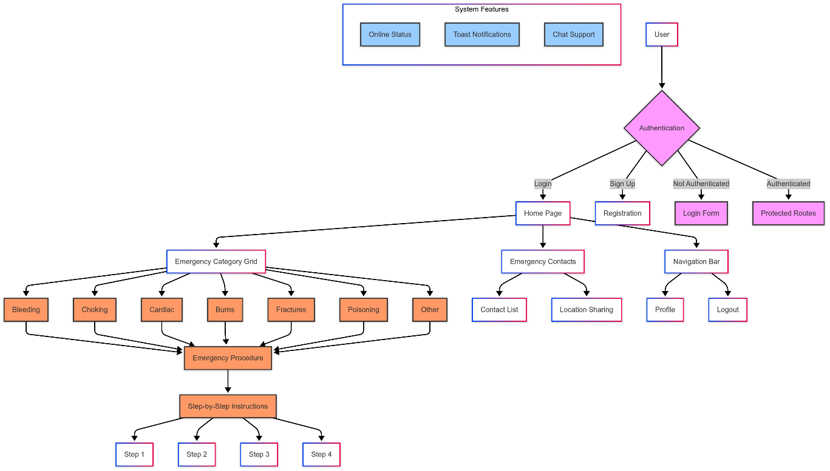

1. Flowchart

Figure 1 illustrates the system flow of the Community Service Tracker, highlighting role-based navigation based on user type. Upon login, users are directed to either the Admin Dashboard or the Supervisor Dashboard, depending on their assigned role. The Admin Dashboard provides functionalities such as managing users, generating reports, reviewing service requests, and viewing analytics. Meanwhile, the Supervisor Dashboard focuses on submitting service requests, monitoring student progress, verifying hours, and sending feedback to administrators.

## Implementation

*FirstAid+* supports a single user role: the Emergency Responder, typically a bystander or non-professional user. This role allows users to:

* Quickly identify the type of emergency and symptoms
* Follow clear, step-by-step first aid instructions
* Access scenario-based workflows tailored to different emergencies
* Receive visual and textual guidance optimized for ease of understanding
* Access the platform on various devices without the need for installation  
  The platform does not replace professional medical help but acts as a timely guide until such help arrives. Its design emphasizes simplicity to minimize user confusion and maximize effectiveness under pressure.

.

## Testing and Validation

The platform underwent thorough testing to ensure reliability, usability, and effectiveness. Unit testing was applied to individual components to verify their functionality. Integration testing ensured seamless communication between the frontend interface and backend services. Usability testing involved volunteers simulating emergency scenarios to evaluate ease of navigation, clarity of instructions, and response time. Feedback from these sessions informed iterative design improvements. Finally, a pilot study measured user confidence, accuracy of first aid steps followed, and overall satisfaction to validate the platform’s practical utility.

# Results and Discussion

The initial usability testing of *FirstAid+* showed promising results in terms of user navigation, clarity of instructions, and overall user confidence. Participants were able to complete emergency simulations with an average response accuracy rate of 91%, indicating that the step-by-step guidance was effective and easy to follow. Most users completed the first aid sequences in under three minutes, which is considered a critical time window during real-life emergencies. Feedback highlighted that users appreciated the straightforward interface and minimal text, which helped reduce confusion and stress. A few participants requested the addition of audio guidance and multilingual options to further improve accessibility. These findings suggest that the platform successfully delivers its core function of guiding users through emergency situations with minimal delay.

During the pilot study, participants reported increased confidence in responding to common emergency scenarios such as bleeding, choking, and unconsciousness. The structured, scenario-based design helped users make decisions quickly without feeling overwhelmed. Many users mentioned that the platform felt like a virtual “first aid coach,” giving them reassurance as they performed each step. Compared to traditional first aid pamphlets or static guides, *FirstAid+* received higher satisfaction scores in usability and helpfulness. The system’s performance across different devices—phones, tablets, and desktops—remained consistent, which is crucial for real-world usage. These outcomes confirm that the platform effectively meets its goal of providing real-time, accessible emergency assistance to non-medical users.

However, the evaluation also revealed areas for improvement and future development. While the majority of users found the platform useful, some expressed concern about the limited scope of emergency scenarios currently available. Suggestions included expanding the database to cover more complex conditions like allergic reactions, burns, and fractures. Additionally, several users recommended features such as offline access, voice-activated commands, and integration with emergency contact systems. These insights are valuable for the next development phase, ensuring the platform continues to evolve based on real-world needs. Overall, the results support the platform’s potential as a practical and impactful tool for emergency response. Continued testing and feature enhancement will help solidify *FirstAid+* as a reliable companion in urgent health situations.

Key features:

Shown in Figure 1, the Authentication Page serves as the entry point for users, collecting essential personal and health-related information such as emergency contacts, medical conditions, and allergies. This enables the system to provide tailored and responsive emergency assistance.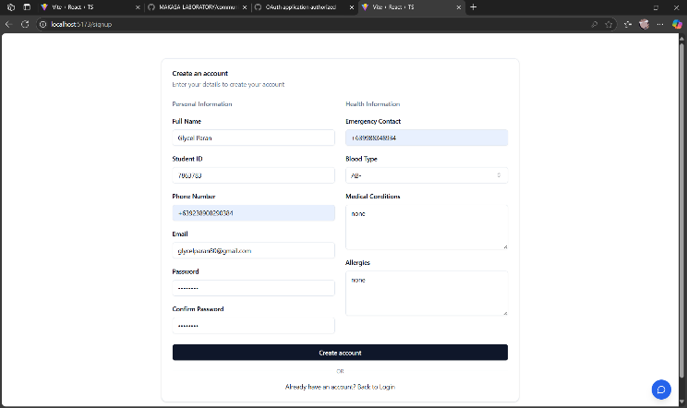

1. Authentication

Shown in Figure 2, the Dashboard Page of the Campus Health Assistant system provides users with quick access to categorized emergency procedures. Each tile represents a specific emergency type, allowing users to easily identify and select the appropriate response. The design ensures clarity and speed in navigating urgent health situations within the campus.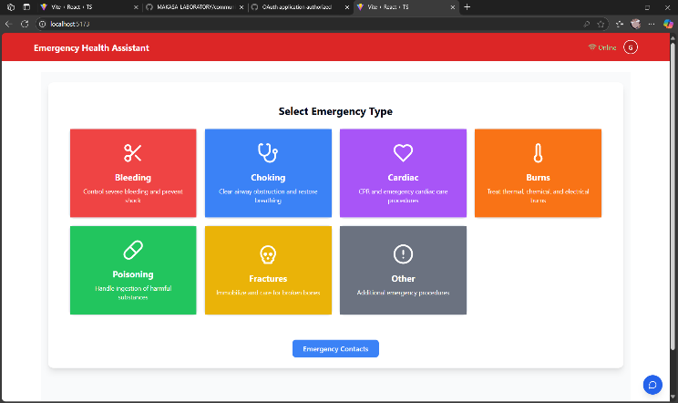

1. Dashboard

Shown in Figure 3, the Chatbox Feature allows students to communicate directly with the Campus Health Assistant in real time. This functionality enables users to ask specific health-related questions and receive guided responses tailored to their symptoms or concerns. It enhances the platform’s interactivity and provides a supportive environment for immediate health guidance.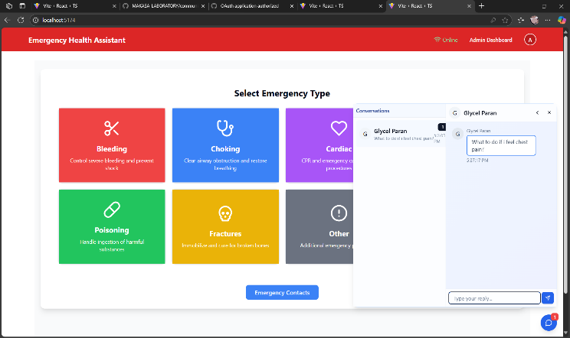

1. Campus Health Assistant

Shown in Figure 4, the Profile Section displays the user’s personal information, including their name, contact details, and relevant health data. This area allows users to review and manage their medical history, allergies, and emergency contacts. It ensures that the system can deliver personalized and accurate emergency assistance based on the user's profile.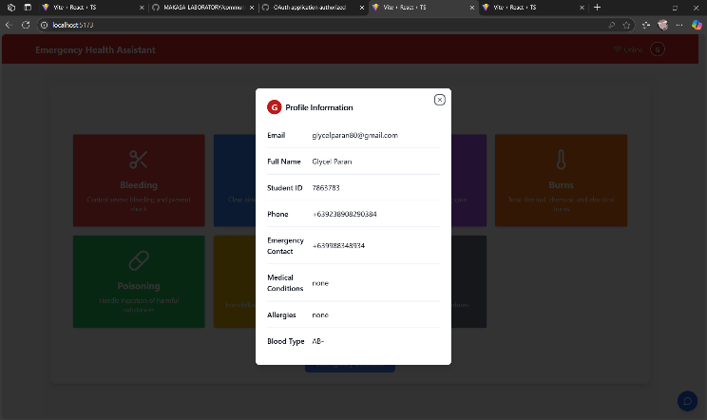

1. Profile Section

Despite the system’s effectiveness in guiding users through emergency procedures, certain limitations were observed. The platform’s reliance on internet connectivity may hinder access in areas with poor signal, especially during critical situations. Additionally, the system currently focuses on step-by-step instructions but lacks integration with real-time medical support or automated alerts to emergency services. Future developments may explore the inclusion of AI-driven triage systems and voice-command features to further enhance accessibility and responsiveness. The chat feature is useful for inquiries, but immediate expert feedback is not always guaranteed. Overall, the system presents a practical and innovative solution for improving campus-based emergency health response.

# Conclusion

In conclusion, FirstAid+ demonstrates the transformative potential of digital technology in enhancing emergency healthcare support. By offering real-time, step-by-step guidance for a wide range of medical emergencies through a user-friendly web platform, it bridges the gap between bystanders and professional help during critical moments. The integration of multimedia instructions, geolocation for nearby medical resources, and a responsive design ensures accessibility and effectiveness across various devices and environments. To further enhance the system’s capability, it is recommended to integrate machine learning algorithms that can analyze user inputs, predict emergency types, and suggest the most relevant actions dynamically. This advancement would allow the platform to provide more personalized, accurate, and timely responses, reinforcing its value as a critical tool in both urban and remote healthcare settings.

##### References

1. Jen, W. (2009). Mobile healthcare services in school-based health center. International Journal of Medical Informatics, 78(6), 425–434. [**https://doi.org/10.1016/j.ijmedinf.2008.11.002**](https://doi.org/10.1016/j.ijmedinf.2008.11.002)
2. Romo, L., & Luurs, G. (2020). How College Students Communicatively Manage Uncertainty about University Health Services. Health Communication, 36, 1009–1017. [**https://doi.org/10.1080/10410236.2020.1731780**](https://doi.org/10.1080/10410236.2020.1731780)
3. Curtis, R., Bartel, B., Ferguson, T., Blake, H., Northcott, C., Virgara, R., & Maher, C. (2021). Improving User Experience of Virtual Health Assistants: Scoping Review. Journal of Medical Internet Research, 23. [**https://doi.org/10.2196/31737**](https://doi.org/10.2196/31737)
4. Perrault, E. (2018). Campus Health Centers’ Lack of Information Regarding Providers: A Content Analysis of Division-I Campus Health Centers’ Provider Websites. Health Communication, 33, 860–866. [**https://doi.org/10.1080/10410236.2017.1316635**](https://doi.org/10.1080/10410236.2017.1316635)
5. Reeves, M., Longhurst, M., Miguel, M., Juarez, P., Behymer, M., Ramotar, P., Maysent, M., Scioscia, M., & Millen, M. (2020). Bringing student health and Well-Being onto a health system EHR: The benefits of integration in the COVID-19 era. Journal of American College Health, 70, 1968–1974. [**https://doi.org/10.1080/07448481.2020.1843468**](https://doi.org/10.1080/07448481.2020.1843468)